

Year 7 Algebra Investigation
Validation Test
2015
Term 1, Semester 1
Instructions:
This investigation consists of three parts.
The first task will be completed in class with your teachers.
The second will be completed at home in your own time using the information you gathered in class. It will account for 30% of this investigation
You will be able to ask your teacher questions about the second task you completed at home before completing an in class validation.
This validation test will expand on what you learnt in the first two tasks and will account for 70% of your mark for this investigation.
You will need the following items:
- Ruler
- Calculator
- Pen/Pencil

Name:________________________________
Investigation Due Date:__________________ Mark:____/ 10 x 30 = _____
Validation Test:________________________ Mark:____/ 25 x 70 = _____

TASK 3 – MATCHSTICK SQUARES

- Consider the following pattern created with matches.

Row 1

Row 2

Row 3

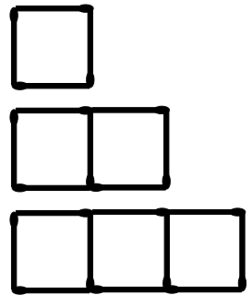

Draw in the next row. [1]
Row 4

- Complete the following table. Use the diagram to help you. You may draw additional diagrams to help you. [2.5]
s (number of squares) | 1 | 2 | 3 | 4 | 6 | 20 | n
m (number of matches) | 4 | 8

- Describe in your own words what is happening in the pattern above [1]
_________________________________________________________________________________________________________________________________________________________________________________________________________________________________

- Complete the following flow diagrams, representing the relationship between the number of hexagons and the number of matches. [2]
S
number of squares
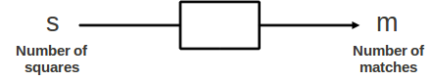
S
number of squares

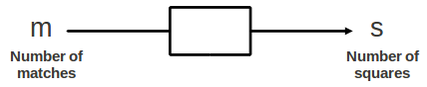
- Write down the formula for calculating the number of matches (m) required if we want to create a certain number of squares (s). [1]

- Write down the formula for calculating the maximum number of squares (s) we could create if we have a certain number of matches (m). [1]

- Complete the table. Use your formulae or flow charts to assist you. [1.5]
s (number of squares) | 36 |  | 52
m (number of matches) |  | 480

- Consider the following pattern created with matches.

Row 1

Row 2

Row 3

Draw in the next row. [1]
Row 4

- Complete the following table. Use the diagram to help you. You may draw additional diagrams to help you. [2]
s (number of squares) | 1 | 2 | 3 | 4 | 6 | 20
m (number of matches) | 4 | 7

- Describe in your own words what is happening in the pattern above [1]
_________________________________________________________________________________________________________________________________________________________________________________________________________________________________
- Describe using the example above how you work out that the pattern flow chart or formula is m = t x 3 + 1 and not m = 4 x t [1]
___________________________________________________________________________
___________________________________________________________________________
___________________________________________________________________________
- Complete the following flow diagrams, representing the relationship between the number of squares and the number of matches. [4]
m
number of matches
m
number of matches

S
number of squares

S
number of squares
- Write down the formula for calculating the number of matches (m) required if we want to create a certain number of squares (s). [2]

- Write down the formula for calculating the maximum number of squares (s) we could create if we have a certain number of matches (m). [2]

- Complete the table. Use your formulae or flow charts to assist you [2]
s (number of squares) | 12 |  | 20
m (number of matches) |  | 88 |  | 145

